Action Together Volunteer Centre
Description | The Volunteer Centre team, within Action Together, work to promote and celebrate volunteering across Oldham. Our team offer support, information and guidance to residents on a wide range of volunteering opportunities.  We work closely with hundreds of community, voluntary, faith and social enterprises and hold details of volunteer roles to offer a one stop shop for all things volunteering.  We can help you make an informed choice before you embark on your volunteer journey, offering lots of local and up to date information. Feel free to phone to make a confidential, informal appointment with Alishia or Uzma!
Days/times | Monday – Friday 9:30am – 4:30pm
Price | Free
Address | Action Together  Unit 12 Manchester Chambers  West Street  OL1 1LF
Picture of building | 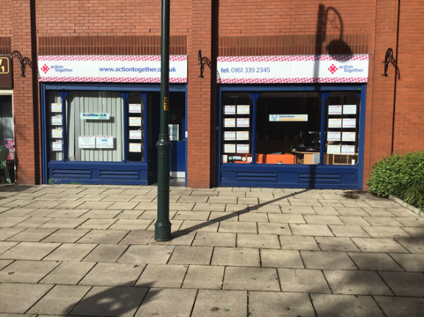
Public transport | Short walk from Oldham Central bus station, Oldham Central tram stop and King Street tram stop
Telephone number | 0161 339 2345
Other info | Website: www.actiontogether.org.uk/volunteer/search-for-opportunities
Learning Disability Friends | Alishia Ross, Uzma Khaliq

