CALM (Come and Let’s Meet)
Description | CALM is a friendship group meeting in the church lounge on Monday afternoons. Have a chat, enjoy a cup of tea and biscuits. All welcome.
Days/times | Every Monday 2pm – 3pm
Price | Free
Address | Roman Road Independent Methodist Church  38 Hedges Street, off Roman Road  Failsworth  M35 9JR
Picture of building | 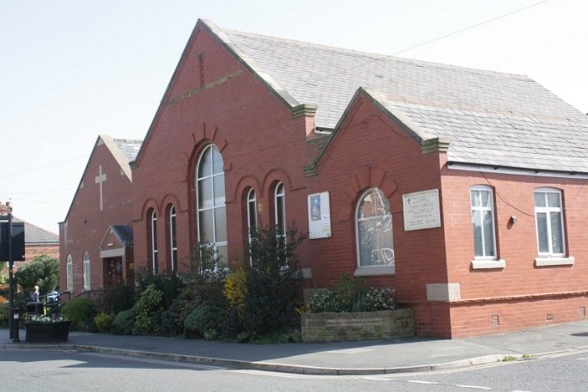
Public transport | The following services stop a short walk away on Ashton Road: 74, 76, 76A, 151, 159, 396, 833  0.7 miles from Failsworth tram stop
Telephone number | 0161 682 4761
Other info | Church website: www.romanroadimchurch.org.uk  Church email: office@romanroadimchurch.org.uk
Learning Disability Friends | Dorothy Kendrick

