Mills Hill Leisure Group
Description | Come and join us for visiting speakers and social events! Most people who come are over 60 but we welcome younger adults as well
Days/times | Fortnightly on a Monday 2pm – 3:30 pm  (next few dates: 19th August, 2nd September, 16th September, 30th September, 14th October, 28th October)
Price | £2 donation
Address | Mills Hill Community Hall  Mills Hill Road  Middleton  M24 2FD
Picture of building | 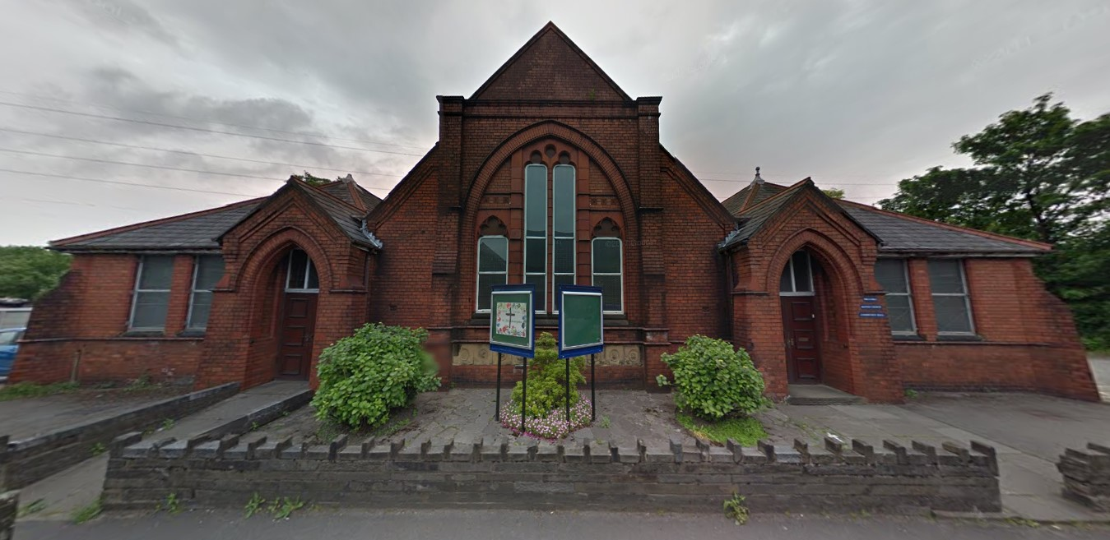
Public transport | The 419 and 788 buses stop outside on Mills Hill Road
Telephone number | Church office: 0161 637 1511
Other info | Church website: www.millshillbaptistchurch.org  Church email: millshillbaptist@gmail.com
Learning Disability Friend | Ruth Pate

