Sholver & Moorside: Early Help Drop-in with Debbie
Description | Free help for you and your family.  Do you or a family member need practical help to support you to take control of your life?  Do you and your family have difficulties such as housing, money, parenting, confidence, looking for work or want to improve an area of your life?  Early Help can provide you with an allocated Engagement Worker to help you develop the skills to help yourself. There are different levels of support available depending on your needs.
Days/times | Every Tuesday: Drop-in between 10am – 1pm
Price | Free
Address | Sholver and Moorside Community Centre  Sholver Lane  OL1 4NT
Picture of building | 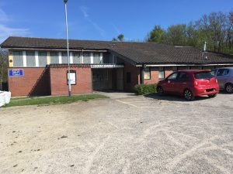
Public transport | The 83 bus stops a short walk away on Longfellow Crescent
Telephone number | Please contact OPAL on 0161 633 5544 if you want us to tell the centre you are going
Other info | Website: www.sholvercommunitycentre.co.uk/  There are lots of other activities going on at Sholver on a Tuesday. Come along for a coffee and a chat. Food is available for a small price at lunchtime.
Learning Disability Friend | Rose Johnstone

