NEON Men’s Group
Description | The Men’s Group was set up to address the needs of socially isolated or lonely men.  Unlike many women, men have difficulty expressing their feelings, worries and issues.  The group aims to address these in an open and free environment without judgment. We try to provide a way in which men can support each other and develop greater self-esteem, become less isolated, more active and physical and mentally healthy.  Activities have included trips to Chester, Manchester and Ashton; healthy cooking and eating classes; Tai Chi classes; art as therapy class; pitch and putt golf; talks from MIND and a drugs counsellor.
Days/times | Every Tuesday 12pm - 2pm
Price | Free
Address | NEON Hub  Holt St  Greenacres  OL4 2DQ
Picture of building | 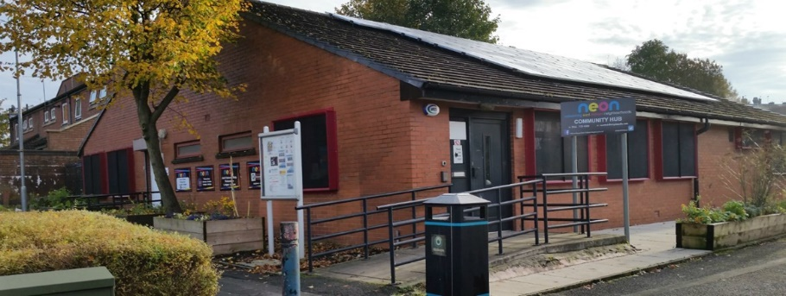
Public transport | These buses stop a short walk away on Huddersfield Road: 350, 410, 411, 558 803, 836, 839, 865
Telephone number | Steve: 0786 805 4700
Other info | Hot drinks are available for 50p  NEON phone numbers: 0161 770 4589; 07305 570 202  NEON website: www.neonoldham.co.uk  NEON email: neonhub@virginmedia.com
Learning Disability Friend(s) | Steve Yorke, Keith Taylor-Bradley

